Get Your
LARSON TRACK SHIRT
Today!

If you are interested in purchasing a SHORT SLEEVE, Neon Yellow Larson Track t-shirt, complete and return this order form to your coach by:

Wednesday, April 26th

Each shirt costs $10.00

* Parents and athletes – please pay by EXACT CASH only. Change cannot be given.

Name
Check next to the size you want. (Adult sizes only) |  |  |  | Check next to the team you are on.
 | Small |  | 8th Grade Girl
 | Medium |  | 7th Grade Girl
 | Large |  | 8th Grade Boy
 | X-Large |  | 7th Grade Boy
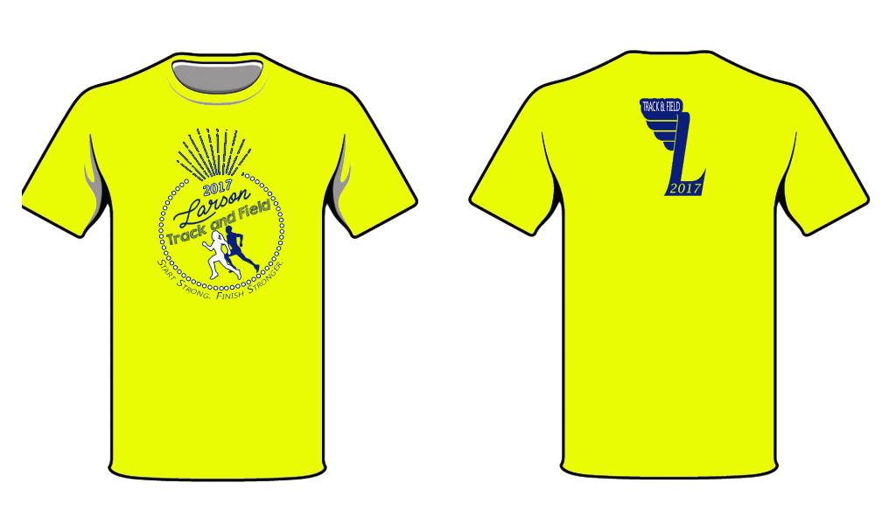
XX-Large

